**Name: Kevin Chacko Abraham**

**Roll No: 13**

**Batch: b**

**Date:23-05-2022**

**NETWORKING & SYSTEM ADMINISTRATION LAB**

**Experiment No.: 24**

**Aim**

Installation of Docker on Ubentu

**Procedure**

step 1: Open the terminal on Ubuntu.

Step 2: Remove any [Docker files](https://www.simplilearn.com/tutorials/docker-tutorial/what-is-dockerfile) that are running in the system, using the following command:

$ sudo apt-get remove docker docker-engine docker.io

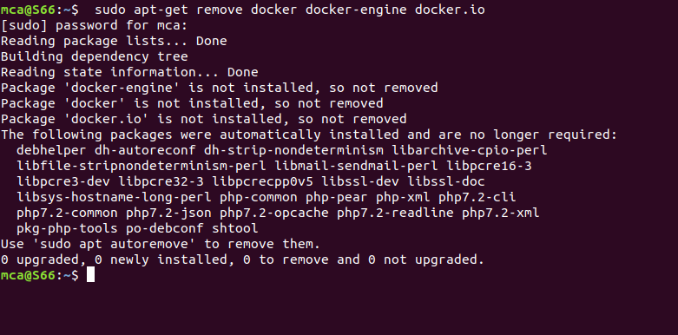

step 3: Check if the system is up-to-date using the following command:

$ sudo apt-get update

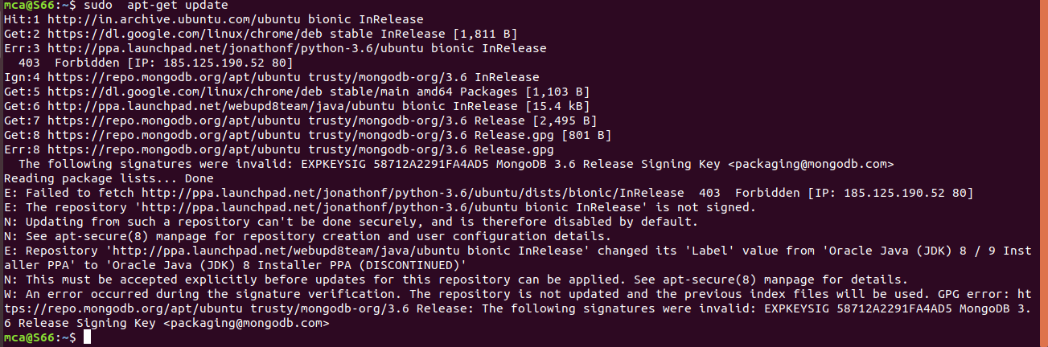

Step 4: Install Docker using the following command:

$ sudo apt install docker.io

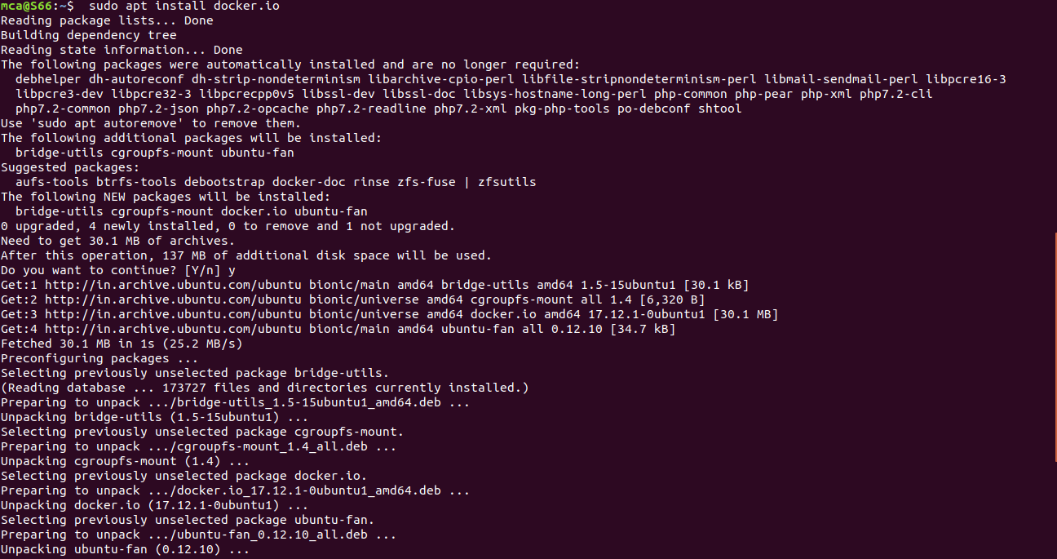

Step 5: Install all the dependency packages using the following command:

$ sudo snap install docker



Step 6: Before testing Docker, check the version installed using the following command:

$ docker --version



Step 7: Pull an image from the Docker hub using the following command:

$ sudo docker run hello-world

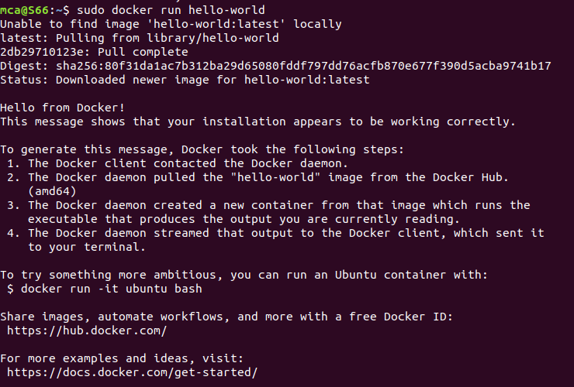

Step 8: Check if the docker image has been pulled and is present in your system using the following command:

$ sudo docker images



Step 9: To display all the containers pulled, use the following command:

$ sudo docker ps -a



Step 10: To check for containers in a running state, use the following command:

$ sudo docker ps

